



|  |
| --- |
| **APWIS**  Automated Plant Watering and Irrigation System  **Team 25**Watering and Irrigation System  Team 25  APWIS has been designed in order to achieve the main objective of maintaining the well-being of a garden in relation with the Internet of things (IoT), while conserving water through efficient distribution methods to prevent shortage or excessive supply. With the versatility of present tools & software, the real-time status of plants is monitored through integrated sensors. Moisture readings are continuously reported by the moisture sensor and sent to the assigned IP address. The Web application linked with the system allows users to access data and undertake necessary actions as per the requirement. In simpler terms, this can be considered as “Smart Irrigation System”. |
|  |

# Abstract

The Smart Irrigation System is developed in order to enhance the water usage for agricultural crops. So, this system has been designed with the main aim of fulfilling the proper wellbeing and the proper maintenance of the garden in relation with Internet of things (IoT), while conserving water through efficient supply methods by preventing shortage and excessive supply of water. This system is a distributed wireless network with sensors that measure soil moisture and temperature respectively that are placed near the root zone of the plants. Then an algorithm was enhanced including the threshold values of temperature and soil moisture. Next that algorithm was programmed into a microcontroller-based gateway that controls the quantity and the supply of water.

# Table of content

Abstract 3

Table of content 3

List of figures 4

List of tables 5

**1.** **INTRODUCTION** 6

**2.** **SYSTEM DEVELOPMENT** 11

**3.** **IMPLEMENTATION** 17

**4.** **SYSTEM TESTING AND QUALITY ASSURANCE** 19

**5.** **CONCLUSION AND FURTHER WORK** 26

**6.** **APPENDIX** 28

# List of Tables

Table 1-Group member details 8

Table 2-Timeline 9

Table 3-member 1 12

Table 4-member 2 13

Table 5-Member 3 14

Table 6-member 4 15

Table 7-member 5 16

Table 8-Testing 1 22

Table 9-testing 2 23

Table 10-Testing 3 23

Table 11-Testing 4 24

Table 12-Testing 5 24

Table 13-Economic feasibility 37

Table 14-Operational feasibility 38

Table 15-Technical feasibility 39

Table 16-Budget 40

Table 17-error 1 51

Table 18-error 2 51

# List of figures

Figure 1-Prototype 31

Figure 2-block diagram 31

Figure 3-Class diagram 41

Figure 4-Highlevel diagram 42

Figure 5-ER diagram 43

Figure 6-Homepage 1 47

Figure 7-homepage 2 47

Figure 8-controller page 1 48

Figure 9-controller page 2 48

Figure 10-prototype 1 49

Figure 11-prototype 2 49

Figure 12-prototype 4 50

Figure 13-prototype 3 50

Figure 14-APWIS SYSTEM 50

Figure 15-TESTING 3 52

Figure 16-TESTING 2 52

Figure 17-TESTING 1 52

Figure 18-TESTING 4 52

# **INTRODUCTION**

#### Project Name and Description

**APWIS**

|  |  |  |
| --- | --- | --- |
|  |  | Decorative |
| Scheduled Control  With Web Application    Multi-Sensor Support    Regular Maintenance |  | Automated plant watering & irrigation system |
| **AUTOMATED SYSTEM**  APWIS is an automated smart irrigation system. This system efficiently water and fertilize your plants when they need it most by using automated watering, fertilizing schedules. It creates powerful schedules to care for your garden while your away or busy with other things. You can also take manual control for the registered gardeners.  **ACCURATE SENSOR READINGS**  Gather data through sensors (soil moisture, humidity, and temperature) and give accurate sensor readings. Additional sensors can be connected to the core of the system as further developments as per user wish.    **SAVING RESOURCES**  Using accurate sensor readings and powerful schedules user can reduce water waste. By reducing water waste user can save money. Plants can be given the care when they need it most by spending less time as this system minimizes human involvement. |

#### Group Details

GROUP: **Team 25**

GROUP NAME: **NextGen Insight**

Table 1-Group member details

|  |  |  |  |
| --- | --- | --- | --- |
| Plymouth ID | NSBM ID | Name | Degree Program (SE/CN/CS) |
| 10707207 | 18175 | D.S.W. Gunasekara | SE |
| 10707017 | 18092 | T.M. Bogahawaththa | CS |
| 10707218 | 18595 | G.P.C. Hettiarachchi | SE |
| 10707341 | 18099 | Y.D.N. Ranawaka | SE |
| 10707038 | 18577 | Y.H. Munasinghe | CS |

#### Project Objectives

Destruction of crops by insects and pests, scarcity of water and the change of environmental and climatic conditions can be considered as the commonly encountered drawbacks of the cultivators in remote areas.

Not only the residents in remote areas but also urban residents have a restricted time to maintain their small gardens by watering crops etc. as their daily routine being subjected to a hectic schedule which occupies most of the time in day hours.

Majority of the cultivators tend to water crops without considering the prevailing environmental conditions such as humidity, soil moisture, luminosity since they have lack of knowledge regarding specific conditions.

In conclusion, the objective of this project is to enhance the standards of remote/rural farmers by giving a better technology and thorough understanding in order to gain the maximum productivity, as the cultivators could take necessary actions towards controlled water supply and pesticide prevention with the advantage of remote technology where no physical presence is needed.

#### Scope of the project

The main scope of the project is developing a system that solves most of the problems related to irrigation and agriculture by saving water and, increasing production of crops using minimum quantity of water. It minimizes human involvement in watering operations with increasing watering speed easily. Preserving plants from fungi also a major feature which makes this method sustainable decision to improve the agricultural efficiency.

#### Timeline

Table 2-Timeline

|  |  |  |  |  |  |  |  |  |  |  |  |  |  |  |
| --- | --- | --- | --- | --- | --- | --- | --- | --- | --- | --- | --- | --- | --- | --- |
| WEEK  TASKS | 1 | 2 | 3 | 4 | 5 | 6 | 7 | 8 | 9 | 10 | 11 | 12 | 13 | 14 |
| Select & discuss the Project |  |  |  |  |  |  |  |  |  |  |  |  |  |  |
| Research on Software, Hardware requirements |  |  |  |  |  |  |  |  |  |  |  |  |  |  |
| Make the Project Proposal and Plan |  |  |  |  |  |  |  |  |  |  |  |  |  |  |
| Purchase required equipment |  |  |  |  |  |  |  |  |  |  |  |  |  |  |
| Fitting bottom panel, water pipes & motors |  |  |  |  |  |  |  |  |  |  |  |  |  |  |
| Wiring the Electronics |  |  |  |  |  |  |  |  |  |  |  |  |  |  |
| Sensor Compartment |  |  |  |  |  |  |  |  |  |  |  |  |  |  |
| Make the web Application |  |  |  |  |  |  |  |  |  |  |  |  |  |  |
| Create and connect cloud database |  |  |  |  |  |  |  |  |  |  |  |  |  |  |
| Programming the Arduino Uno and WIFI module |  |  |  |  |  |  |  |  |  |  |  |  |  |  |
| Finish the prototype structure of the system |  |  |  |  |  |  |  |  |  |  |  |  |  |  |
| Planting |  |  |  |  |  |  |  |  |  |  |  |  |  |  |
| Testing sensors and the circuit |  |  |  |  |  |  |  |  |  |  |  |  |  |  |
| Test the whole system using web application |  |  |  |  |  |  |  |  |  |  |  |  |  |  |
| Testing &Corrections |  |  |  |  |  |  |  |  |  |  |  |  |  |  |
| Handover the project |  |  |  |  |  |  |  |  |  |  |  |  |  |  |

#### Summary

This system mainly used in monitoring the levels of moisture of the soil in the agricultural yards giving an idea whether the prevailing condition is better for crop cultivation. This system also provides an idea with the features and drawbacks of the agricultural and irrigation systems used at present. As water is a basic need in crop cultivation and gardening, this proposed system can be used in spreading up of water sprinkles throughout the cultivated land using the water sprinkler by turning it “ON” after measuring the soil moisture conditions. The sensors that measure the soil moisture conditions prevent the damage caused to the plants due to the threats by underirrigation of soil and overirrigation of soil. The farm owner has the ability of monitoring all those conditions online without being at the relevant premises. Finally, we can conclude that the proposed system of “Smart Irrigation System” is a huge potential solution for the farmers who were weeping after affected by the water scarcity.

# **SYSTEM DEVELOPMENT**

#### D.S.W. Gunasekara

Table 3-member 1

|  |  |
| --- | --- |
| Name | D.S.W. Gunasekara (Team Leader) |
| Plymouth ID | 10707207 |
| Completed tasks | * Connecting wires with the sensors and fixing the sensors with the main circuit board * Programming Arduino * Test runs and corrections |
| Used technologies | Micro controller, Arduino Programming |
| Accrued skills and knowledge | * Knowledge on Sensors, Arduino, and Arduino programming * Team work and cooperation * Project management as the leader |
| Comments by the group leader | As the team leader, I guided my team and distributed tasks towards each member considering their strengths and weaknesses while completing my tasks. |

#### T.M. Bogahawaththa

Table 4-member 2

|  |  |
| --- | --- |
| Name | T.M. Bogahawaththa |
| Plymouth ID | 10707017 |
| Completed tasks | * Designing the web application structure and Sketching the Interfaces * Creating the Web Application using HTML, CSS, JS. * Creating Reports, Presentations |
| Used technologies | HTML, CSS, JS |
| Accrued skills and knowledge | * Skills on web designing and HTML, CSS, JS coding. * Creative presentation, report making skills * Communication skills |
| Comments by the group leader | Well committed on tasks such as report making, facts finding & project finalizing |

#### G.P.C. Hettiarachchi

Table 5-Member 3

|  |  |
| --- | --- |
| Name | G.P.C. Hettiarachchi |
| Plymouth ID | 10707218 |
| Completed tasks | * Implementing the cloud database relations, keys, and data * Connecting the database to the Arduino circuit * Implementing the functions between the application and the database |
| Used technologies | Firebase, PHP |
| Accrued skills and knowledge | * Knowledge about Arduino programming * Knowledge on firebase * Time management skills |
| Comments by the group leader | Intellectual talents on logical criteria such as programming & coding |

#### Y.D.N. Ranawaka

Table 6-member 4

|  |  |
| --- | --- |
| Name | Y.D.N. Ranawaka |
| Plymouth ID | 10707341 |
| Completed tasks | * Programming the Arduino * Connecting Arduino with the application * Testing and corrections |
| Used technologies | Micro controller, Arduino Programming |
| Accrued skills and knowledge | * Knowledge on Sensors, Arduino, and Arduino programming * Skills on debugging |
| Comments by the group leader | Specialized skills on creative content such as designing and debugging |

#### Y.H. Munasinghe

Table 7-member 5

|  |  |
| --- | --- |
| Name | Y.H. Munasinghe |
| Plymouth ID | 10707038 |
| Completed tasks | * Purchase hardware components and handling budget. * Planting and maintain plants * Doing test runs and identify any failures and corrections |
| Used technologies | Micro controller, Arduino Programming |
| Accrued skills and knowledge | * Knowledge on Sensors, Arduino, and Arduino programming * Skills on financial handling of the whole project |
| Comments by the group leader | Thorough understanding on utilizing hardware accessories and engaged in practical applications |

#### 

# **IMPLEMENTATION**

#### Project GitHub link



<https://github.com/thxru/APWIS>

#### Implementation of the system

In the projected Irrigation system IoT is enforced, during this system all the knowledge that area unit received from the sensors and therefore the numerous parameters area unit given to the Arduino Uno microcontroller as associate degree analog input.

A predetermined worth of soil wet detector is mounted in microcontroller and conjointly for fencing. once it goes on the far side the actual threshold worth water is mechanically irrigated to the crops and once the specified quantity of water is consummated it stops.

The Microcontroller transmits that info on the net through a network of IoT within the kind of LAN module ESP8266 that's connected thereto. This enhances automatic irrigation because the pump is often switched on or off through info given to the controller.

Working with good Irrigation System victimization IoT in the agriculture field, sensors area unit used like soil wet. the knowledge received from the sensors is shipped to the info folder through the robot device. within the management section, the system is activated victimization the appliance, this is often finished victimization the ON/OFF buttons within the application. Also, this technique is mechanically activated once the soil wet is low, the pump is switched ON supported the wet content.

The application contains a feature like taking your time from the user and water the agriculture field once the time comes. during this system, there's a switch accustomed close the water system if the system fails. different parameters like the wet detector demonstrate the brink worth and therefore the level of water within the soil. Smart Irrigation System victimization IoT Further, this project is often increased by planning this technique for big acres of soil. Also, this project is often incorporated to create certain the worth of the soil and therefore the growth of harvest in every soil.

The microcontroller and sensors area unit with success interfaced and wireless communication is earned between a range of nodes. Also, more this projected system is often increased by adding up machine learning algorithms, that area unit capable to check and acknowledge the requirements of the crop, this may aid the agriculture field to be associate degree automatic system.

The inspections and outcomes tell U.S. that this result is often dead for a modification of water loss and reduce the men necessary for a field. From the on top of info, finally, we will conclude that the hardware parts of this technique interfaces with all the sensors. The system is powered by an influence supply, and therefore the system has been checked for watering associate degree agriculture field.

#### 

# **SYSTEM TESTING AND QUALITY ASSURANCE**

#### Testing approaches and methodologies

Testing approaches can be mainly divided in to two main approaches namely,

* + 1. **Functional Testing**

The main scope of functional testing is testing the application against business requirements of the project. This method mainly proceeds in the below order.

1. Unit Testing

* This is the first step of Functional Testing. The main aim of this testing method is to check whether the developed project and the codes are functional as the way that they are designed to.
* This step is conducted manually. In our Project APWIS, all the sensors were tested separately by connecting to the Arduino Uno micro controller board.
* First, the soil moisture, was tested by inserting the soil moisture sensor in different soil samples that are more favorable for the growth of the plants.
* Unit testing also makes debugging much easier so that, the developers can easily identify the errors easily and then the discovered errors can be solved easily.
* Then we have tested the DHT11 sensor used in measuring the humidity and temperature. By conducting unit testing we have identified that the temperature reading was not accurate and it displayed as 999%. So, it was easier for us to identify the errors and getting steps against those errors.
* This unit testing method was then conducted with the two water level sensors that was used in measuring both water level and the fertilizer level. There we identified that no any errors were found in the readings gained through the sensors.
* Then the solar power 12v motors were tested that is used in pumping both water and fertilizers. The pressure of pumping through that motors were recognized as enough by conducting unit testing.

1. Integration Testing

* After unit testing is conducted, those units are then integrated with different units to create modules that are used to perform specific targeted tasks. This testing is used to check whether the whole segments of this application do work as expected by the development team.
* By the combination of water level sensor, soil moisture sensor and the 12v solar motor the automation of watering has been done in this APWIS system. Automation of adding fertilizers has been also done in the same way by the combination of fertilizer level sensor and the other 12v solar motor. These combinations were tested with different soil samples and different water levels included in the vessels.

1. System Testing

* This testing method is used in order to check whether the whole proposed system meets the specified requirements. One of our group members was assigned to the system testing part and his duty was to check the functionality end to end. Then he approved by going through the project overview and it was then directed for production.

1. Acceptance Testing

* This is the last phase of functional testing. Here, it is checked whether the outcome is ready for delivery. Here, Beta testing is carried out by targeting potential customers and it is checked whether that the outcome is the same as the outcome desired by the users.’
* Here, the APWIS system was given to a colleague of a different group to check whether the required tasks and objectives were clearly fulfilled through our project.

* + 1. **Non – Functional testing**

This includes all the test types focusing on the operational aspects of the system. This consists of 4 main testing methods as in the below order.

1. Performance Testing

* The main aim of Performance testing is to test the responsiveness and how the system is stable in the users’ aspect. Simply it is determined how the application behave under various conditions. Load testing, stress testing, endurance testing and spike testing are the main 4 types of Performance testing.
* Here, moisture level of the soil was tested without water and then it was again measured by adding water to the soil sample and then the soil moisture value was gained.

1. Security Testing

* The main aim of this testing method is to find the loopholes and the risk under security concerns of the developed system. The main basic principles considered under six basic principles namely integrity, confidentiality, authentication, authorization, availability, and non-repudiation.

1. Usability Testing

* This is a method of testing where this whole application’s ease of use with respect to the end user.
* The web application that we have developed for our system was applied under usability testing. It was done under activities such as logging in to the application etc.

1. Compatibility Testing

* Here, the application is then tested under different environments whether the system and the program are compatible with different environments.
* Our system was tested against a family in the rural area who are engaged in farming and that was suitable for their needs and it was also tested against a family in the town area so that, it was tested suitable against them.

#### Test cases

* During the testing of the soil moisture, we got large minus values when the soil moisture is close to zero as well as we got a wrong positive value when water was included in the soil; sample. So, by conducting unit testing we have adjusted that error by adjusting the delay and the ports that the sensors were connected to the controller.
* During the testing of water level sensor, we got the maximum value as 564% when it is totally emersed in water vessel and then we wiped the sensor and kept in the environment and we got the value as 0. So, we needed to find the medium or the midpoint of the water level sensor to display as water level is medium in the LCD panel. So, that we have marked and calculated the mid-level of vessel by different testing methods and got it as 330%.

Table 8-Testing 1

|  |  |  |  |  |  |  |  |  |  |  |  |  |  |  |
| --- | --- | --- | --- | --- | --- | --- | --- | --- | --- | --- | --- | --- | --- | --- |
| **Created By** | | | Group 25 | | **Test Case Description** | | | Automated Plant Watering and Irrigation System | | | | | | |
|  |  |  | |  | |  |  | |  |  |  |  | | | | |  |
|  |  |  | |  | |  |  | |  |  |  |  | | | | |  |
| **Tester's Name** | | | Dineth | | **Date Tested** | | | 20 / 2 / 2021 | | **Test Case (Pass/Fail/Not Executed)** | | | Pass | | |
|  |  |  | |  | |  |  | |  |  |  |  | | | | |  |
| **Test Scenario** | Getting all the sensors connected as a whole and get the readings properly. | | | | | | | | |  |  |  | | | | |  |
|  |  |  | |  | |  |  | |  |  |  |  | | | | |  |
| **Step #** | **Step Details** | | | **Expected Results** | | | **Actual Results** | | | | **Pass / Fail / Not executed / Suspended** | | |
|
| 1 | Making the structure as decided | | | To make the structure | | | As Expected, | | | | Pass | | |
| 2 | To connect the soil moisture sensor and get readings | | | To make the soil moisture sensor work properly | | | As Expected, | | | | Pass | | |
| 3 | To code all the sensors | | | To make all the sensors work | | | As Expected, | | | | Pass | | |

Table 9-testing 2

|  |  |  |  |  |  |  |  |  |  |  |
| --- | --- | --- | --- | --- | --- | --- | --- | --- | --- | --- |
| **Created By** | | Group 25 | **Test Case Description** | | Automated Plant Watering and Irrigation System | | | | | |
|  |  |  |  |  |  |  |  |  | |  | | |  |
|  |  |  |  |  |  |  |  |  | |  | | |  |
| **Tester's Name** | | Dilan | **Date Tested** | | 18 / 2 / 2021 | | **Test Case (Pass/Fail/Not Executed)** | | Pass | | |
|  |  |  |  |  |  |  |  |  | |  | | |  |
| **Test Scenario** | Getting all the sensors connected as a whole and get the readings properly. | | | | | |  |  | |  | | |  |
|  |  |  |  |  |  |  |  |  | |  | | |  |
| **Step #** | **Step Details** | | **Expected Results** | | **Actual Results** | | | **Pass / Fail / Not executed / Suspended** | | | |
|
| 1 | Making the structure as decided | | To make the structure | | As Expected, | | | Pass | | | |
| 2 | To connect the DHT11 sensor and get readings | | To get correct readings about temperature and humidity and check whether the sensor work properly | | As Expected, | | | Pass | | | |
| 3 | To code all the sensors | | To make all the sensors work | | As Expected, | | | Pass | | | |

Table 10-Testing 3

|  |  |  |  |  |  |  |  |  |  |  |
| --- | --- | --- | --- | --- | --- | --- | --- | --- | --- | --- |
| **Created By** | | Group 25 | **Test Case Description** | | Automated Plant Watering and Irrigation System | | | | | |
|  |  |  |  |  |  |  |  |  |  | | |  |
|  |  |  |  |  |  |  |  |  |  | | |  |
| **Tester's Name** | | Tharushi | **Date Tested** | | 15 / 2 / 2021 | | **Test Case (Pass/Fail/Not Executed)** | | Pass | |
|  |  |  |  |  |  |  |  |  |  | | |  |
| **Test Scenario** | Formation of the APWIS web application and making the final report | | | | | |  |  |  | | |  |
|  |  |  |  |  |  |  |  |  |  | | |  |
| **Step #** | **Step Details** | | **Expected Results** | | **Actual Results** | | | **Pass / Fail / Not executed / Suspended** | |
|
| 1 | Making the web application and connecting it to the micro controller | | Making the web application more attractive and eligible for the targeted | | As Expected | | | Pass | |
| 2 | Producing the final report | | Production of the final report according to the structure given | | As Expected | | | Pass | |

Table 11-Testing 4

|  |  |  |  |  |  |  |  |  |  |  |  |
| --- | --- | --- | --- | --- | --- | --- | --- | --- | --- | --- | --- |
| **Created By** | | Group 25 | **Test Case Description** | | Automated Plant Watering and Irrigation System | | | | | | |
|  |  |  |  |  |  |  |  |  | |  | | |  |
|  |  |  |  |  |  |  |  |  | |  | | |  |
| **Tester's Name** | | Yehan | **Date Tested** | | 20 / 2 / 2021 | | **Test Case (Pass/Fail/Not Executed)** | | Pass | | |
|  |  |  |  |  |  |  |  |  | |  | | |  |
| **Test Scenario** | Getting all the sensors connected as a whole and get the readings properly. | | | | | |  |  | |  | | |  |
|  |  |  |  |  |  |  |  |  | |  | | |  |
| **Step #** | **Step Details** | | **Expected Results** | | **Actual Results** | | **Pass / Fail / Not executed / Suspended** | | | |
|
| 1 | Making the structure as decided | | To make the structure | | As Expected, | | Pass | | | |
| 2 | To check whether all the sensors work properly | | To make all the sensors work and the units made using the combination of the sensors work as expected | | As Expected, | | Pass | | | |

Table 12-Testing 5

|  |  |  |  |  |  |  |  |  |  |  |
| --- | --- | --- | --- | --- | --- | --- | --- | --- | --- | --- |
| **Created By** | | Group 25 | **Test Case Description** | | Automated Plant Watering and Irrigation System | | | | | |
|  |  |  |  |  |  |  |  |  |  | | |  |
|  |  |  |  |  |  |  |  |  |  | | |  |
| **Tester's Name** | | Prabashi | **Date Tested** | | 15 / 2 / 2021 | | **Test Case (Pass/Fail/Not Executed)** | | Pass | |
|  |  |  |  |  |  |  |  |  |  | | |  |
| **Test Scenario** | Formation of the APWIS web application and making the final report | | | | | |  |  |  | | |  |
|  |  |  |  |  |  |  |  |  |  | | |  |
| **Step #** | **Step Details** | | **Expected Results** | | **Actual Results** | | | **Pass / Fail / Not executed / Suspended** | |
|
| 1 | Connecting the firebase to the web application | | Passing data from the database to the web application | | As Expected, | | | Pass | |
| 2 | Connecting the wi-fi module used to the firebase | | Passing data read by the sensors to the database | | As Expected, | | | Pass | |

#### Validation of Results

* When we consider the testing under soil moisture, we obtained large minus values when the sensor did not have a connection with water. Then by adjusting the delay of the Arduino code the values were adjusted.
* By reading research articles and the documents that are related to soil levels that are needed for the plantation of the chosen plant by our team (Chillie plant) and the values we obtained were validated as true by comparing favorable values obtained from resources.
* At the process of finding the medium level value displayed on the water level sensor the values obtained through research articles and the data sources were compared with them and validated.

#### Analysis of results

* After validating all the sensor results it was again analyzed.

#### Summary

* First, the sensors namely soil moisture sensor, water level sensor, fertilizer level sensor, DHT 11 sensor that is used in measuring temperature and humidity and the system APWIS formed by the combination of small units was tested under both functional and non-functional testing methods.
* Then the results obtained were validated by comparing with the resources found through resource articles and the information collected from the responsible authorities.
* Then all the results were reanalyzed again to make them perfect.

# **CONCLUSION AND FURTHER WORK**

#### Conclusion

The implemented automated smart watering and irrigation system (APWIS) is realistic and cost-effective in terms of maximizing water supplies for agricultural production. This irrigation system increases sustainability by allowing agriculture in water-scarce areas. APWIS determines that water consumption can be reduced for a given amount of area. Automated fertilizing and watering reduced human involvement and save user time.

#### Limitations

* APWIS is limited to a single field and a single plant type.
* The APWIS system was created solely for the use of one user.
* The plantation was limited up to a small area where the size of 30cm*30cm and the length of the pipes were small too.
* APWIS is limited in measuring conditions such as water level, fertilizer level, soil moisture level, temperature and the humidity levels that are favorable for growth of plants.

#### Further work

* + - APWIS web will be expand to the use of multiple users.
    - A single user can insert multiple fields and plant types into the system.
    - The consumer has web-based control over each plant type and area.
    - At the end of the week or month, users will be able to download review reports.
    - This system will be automated with lighting system so that the favorable light conditions that will be needed for a plant’s growth will be monitored.
    - The pipes that have used now will be replaced with nozzles so that all the plants will be getting the same amount of water.
    - This system will be developed in a way that every single plant is monitored individually while things such as adding water and fertilizers will be done per plant.

#### Summary

This system mainly used in monitoring the levels of moisture of the soil in the agricultural yards giving an idea whether the prevailing condition is better for crop cultivation. This system also provides an idea with the features and drawbacks of the agricultural and irrigation systems used at present. As water is a basic need in crop cultivation and gardening, this proposed system can be used in spreading up of water sprinkles throughout the cultivated land using the water sprinkler by turning it “ON” after measuring the soil moisture conditions. The sensors that measure the soil moisture conditions prevent the damage caused to the plants due to the threats by underirrigation of soil and overirrigation of soil. The farm owner has the ability of monitoring all those conditions online without being at the relevant premises. Finally, we can conclude that the proposed system of “Smart Irrigation System” is a huge potential solution for the farmers who were weeping after affected by the water scarcity.

# **APPENDIX**

#### Project Proposal

* + 1. Introduction

In this current era, the world has faced a major problem regarding water scarcity. Considering the requirements of Agricultural sector, the cultivators are subjected to a severe condition since water is the basic need of agriculture. Even though the Drip Irrigation system saves large amounts of water, it is not always applicable since the amount of water required for crops cannot be predicted & the values may vary often. The proposed system has been designed in order to achieve the main objective of maintaining the well-being of a garden in relation with the Internet of things (IoT), while conserving water through efficient distribution methods to prevent shortage or excessive supply. With the versatility of present tools & software, the real-time status of plants is monitored through integrated sensors.

* + 1. Project Objectives

Destruction of crops by insects and pests, scarcity of water and the change of environmental and climatic conditions can be considered as the commonly encountered drawbacks of the cultivators in remote areas.

Not only the residents in remote areas but also urban residents have a restricted time to maintain their small gardens by watering crops etc. as their daily routine being subjected to a hectic schedule which occupies most of the time in day hours.

Majority of the cultivators tend to water crops without considering the prevailing environmental conditions such as humidity, soil moisture, luminosity since they have lack of knowledge regarding specific conditions.

In conclusion, the objective of this project is to enhance the standards of remote/rural farmers by giving a better technology and thorough understanding in order to gain the maximum productivity, as the cultivators could take necessary actions towards controlled water supply and pesticide prevention with the advantage of remote technology where no physical presence is needed.

* + 1. Background and Motivation

Due to the prevailing situation related with COVID-19, cultivators have faced many difficulties since most of the cultivations were destroyed due to scarcity of water and from the damages done by the insects as the cultivators couldn’t go to their cultivated areas because most of the areas were locked down. It is one of the main reasons for motivating us to propose this project. By this project we can store water, insecticides & take necessary steps with the usage of this application.

Another reason for motivating us to propose this project was the television and the other mass media reporting about the destruction of the cultivated areas and about the loss of harvest due to lack of water and insecticides during the pandemic period.

Some cultivators in remote areas were killed by elephants while they were in their cultivated areas watering crops and spraying insecticides and pesticides. So, by using this app the cultivators could ensure the maintenance without going to their cultivated areas as it could be done at home which will help us to prevent loss of innocent lives in future.

* + 1. Approach

How APWIS differ from existing Irrigation systems

Properly scheduled pesticide spraying is a key feature of APWIS which make this project unique from existing systems.

Benefits which APWIS gives to the client/potential users.

* Save money by reducing water waste.
* Improved health and beauty of landscape.
* Smart irrigation controllers help you reduce loss of hardscape.
* Avoid fines with your smart irrigation controller.
* Maintain the quality of crops.
* Proper pesticide distribution helps to protect crops.

Technology used in APWIS

If categorized generally, there are two types of smart irrigation technology; soil moisture based and water-based. Even though both technologies proven to conserve water, moisture-based system is chosen in this project as it is advantageous on fulfilling most of the common requirements.

In this technology, the time of water irrigation is adjusted by measuring the readings of soil moisture content, which are generated by moisture sensors. As with weather-based systems, moisture-based systems are promoted both as integrated controllers and as add-on technology. As well as the versatility, expenses of these technologies vary significantly.

Two distinct types of moisture-based systems can be found in present days, naming suspended-cycle irrigation & moisture-based smart irrigation. Referring to the first method, uses a traditional timed & automated watering schedule. If the soil moisture threshold becomes high the water supply will be interrupted which makes the only difference between two systems. However, pre-programmed schedule of additional watering will not be adjusted if the soil is too dry. Many of these sensors can be integrated to an existing traditional controller.

Referring to the water-on-demand system, two soil moisture thresholds (high and low) are maintained providing water supply automatically on necessity. In this type, when replacing the existing controller, a controller with its own sensors is required.

Here we use the moisture-based smart irrigation system as this method is an extremely efficient set up because it allows more site data to be programmed.

* + 1. Methodology

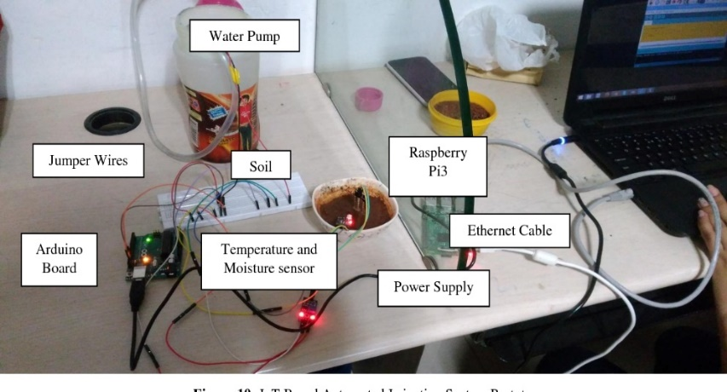[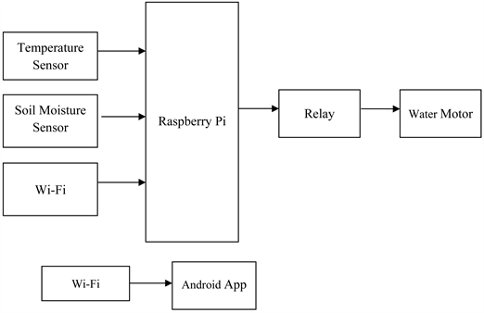](https://html.scirp.org/file/83708x2.png)

Figure 1-Prototype

Figure 2-block diagram

Block diagram of the system

Prototype of the system

A prototype as shown above is being developed in this project by using Arduino Uno board, Pipes, , Soil Moisture Sensor Module, Water Pump Module, Relay Module, Connecting Wires etc.

Moisture conditions are monitored through an electronic device which is embedded with a Bluetooth device. Calibrated environmental conditions are recorded and sent to the server database. Soil moisture values are sensed by the sensor node deployed in irrigation field and sent to the controller node. The required soil moisture value is determined by the controller node when sensor value is received. If soil moisture value in irrigation field doesn’t meet up the standards, he automated irrigation process is taken place and alert message is sent to the authentic mobile phone. Diminution of moisture in existing plants is estimated and measured by smart irrigation systems in order to prevent excessive water use in restoration process. A proper irrigation schedule is strictly needed to improve water efficiency as it is depended on irrigation frequency, amount of irrigation water and water usage.

* + 1. Resource Requirements

**Hardware components**

* A strong flexible sheet (180cm * 275cm)
* PVC pipes (30cm of length)
* 1’’ wood plank of pine (300cm*10cm)
* Surgical tubes (250cm)
* ¼’’ plywood board (120cm*80cm)

**Electronic components**

* Arduino Uno
* LCD Display Green
* Project board
* Water Pump
* 12V solar Power Motor*2
* Moisture Sensor
* Temperature Humidity Sensor
* Uno Wi-Fi Module
* Water Level Sensor

**Software requirements**

* Microsoft Visual Studio code
* Firebase
* Arduino IDE

#### Technical specification

* + 1. Introduction
       1. Definition of the problem

Due to the prevailing situation related with COVID-19, cultivators have faced many difficulties since most of the cultivations were destroyed due to scarcity of water and from the damages done by the insects as the cultivators couldn’t go to their cultivated areas because most of the areas were locked down. It is one of the main reasons for motivating us to propose this project. By this project we can store water, insecticides & take necessary steps with the usage of this application.

Another reason for motivating us to propose this project was the television and the other mass media reporting about the destruction of the cultivated areas and about the loss of harvest due to lack of water and insecticides during the pandemic period.

Some cultivators in remote areas were killed by elephants while they were in their cultivated areas watering crops and spraying insecticides and pesticides. So, by using this app the cultivators could ensure the maintenance without going to their cultivated areas as it could be done at home which will help us to prevent loss of innocent lives in future.

* + - 1. Project Objectives

Destruction of crops by insects and pests, scarcity of water and the change of environmental and climatic conditions can be considered as the commonly encountered drawbacks of the cultivators in remote areas.

Not only the residents in remote areas but also urban residents have a restricted time to maintain their small gardens by watering crops etc. as their daily routine being subjected to a hectic schedule which occupies most of the time in day hours.

Majority of the cultivators tend to water crops without considering the prevailing environmental conditions such as humidity, soil moisture, luminosity since they have lack of knowledge regarding specific conditions.

In conclusion, the objective of this project is to enhance the standards of remote/rural farmers by giving a better technology and thorough understanding in order to gain the maximum productivity, as the cultivators could take necessary actions towards controlled water supply and pesticide prevention with the advantage of remote technology where no physical presence is needed.

* + 1. System Analysis
       1. Facts gathering techniques

Already, the farmers of the European developed countries use various new technologies in their daily activities.

As an example, Modern farmers use various kinds of sensors in order to get a detailed description of their cultivated lands with the aim of examining the condition of the soil.

At present, Smartphone applications are rapidly used mainly for the purposes of examining the growth and the productivity of the plant and referring to the market value changes through them. IoT plays a main role in connecting all those modern innovations making the field of agriculture an easier process to attend in.

Although a proper implementation for the Watering system is not yet being in use due to Sri Lanka's lack of technological advancement and still being a developing country.

Due to this reason an existing system cannot be taken into consideration in analysing of the system through fact finding methods.

* + - 1. Current system & Drawbacks of the current system

But as for the Sri Lankan farmer these types of technologies which makes their tasks easier are not yet implemented in a huge scale. Although they are yet being the victim of the mafias persisting among the society.

The current irrigation system of Sri Lanka is mainly nourished through the rivers and the water resources which are a blessing to a small island as such. The water flowing from rivers our gathered up making large reservoirs and then being distributed to the crops through the small path called "ala para", The farmer needs to keep constant eye on the crop to be sure that the crop receives enough water for its need as water is the most crucial factor of the harvest’s quality and health.

Not only the farmer is insolvent of this method but also as water is a scarce resource. the proper utilization of water needs to be considered as the most urgent issue in the current scenario of water decreasing and drying up of rivers and tanks. The bad and dry environmental conditions that prevail these days causes decreasing the level of water and drying the resources namely reservoirs, rivers, and tanks. Therefore, the proper utilization of water is the main issue that is to be considered these days by the farmers and the people who engage in large scale/small scale farming.

Therefore, Traditional irrigation strategies do not have the ability of dealing up with the problems regarding the scarcity of water. So, modern techniques and methodologies are the only aids for the above-mentioned problem.

The advantages mentioned below can be gained through the Smart Irrigation System.

* Reducing the consumption of water.
* Less amount manpower required. Sometimes manpower is not required.
* Reduction of soil erosion and the leakage of nutrition.
* Increase the productivity
* Productive Cost methods.
* Having high quality crops and yield.
* Efficient use of water.
  + 1. Requirement Specification

Analysis of the system requirement based on different factors such as strength, quality, easy to implement, modifiability etc.

* + - 1. Functional requirements
* Monitor the soil moisture
* Monitor the temperature and humidity
* Operate in manual and automatic irrigation controls mode
* allow to control the irrigation manually
* Actuator control Requirements
  + - 1. Non-functional requirements
* Create circuit with outer box to prevent entry of dust and water
* Performance of agriculture management system
* Cost of hardware
* Input supply voltage of 12v
  + - 1. Performance requirements
* Shall be able to run app on android smartphone above 4.1(jelly bean)
* Shall be able to program on laptop with windows 7 or above with minimum 8gb RAM
  + - 1. Hardware requirements
* A strong flexible sheet (180cm * 275cm)
* Wires
* 1’’ wood plank of pine (300cm*10cm)
* Surgical tubes (250cm)
* ¼’’ plywood board (120cm*80cm)
* Arduino Uno
* LCD Display Green
* Project board
* Water Pump
* 12V solar Power Motor*2
* Moisture Sensor
* Temperature Humidity Sensor
* Uno Wi-Fi Module
* Water Level Sensor
* Laptop
* PC with Internet Connection & web browser
  + - 1. Networking requirements (optional)
* Wi-Fi connection for an IP allotment
  + 1. Feasibility Study

The process that checks the capability of developing a proposed system and implementing that proposed system according to the internal or external factors that impact on it.

Feasibility Study tests the proposed system under the criteria workability, cost effectiveness, achievement of user requirements, productive use of resources and, etc.

Feasibility study requires the analysis of both internal and external factors of the system. This helps in determining whether this organization can continue with this project.

This also gives the organization an idea about the risks that the organization can face during the development of this project.

Types of feasibility studies can be categorized as follows,

1. Economic feasibility
2. Operational feasibility
3. Technical feasibility
4. Organizational feasibility

Feasibility study of our **SMART IRRIGATION SYSTEM** will be explained in relation with above mentioned topics.

* + - 1. Economic feasibility

Economic feasibility defines the capability of building the proposed system under available resources. Economic feasibility is identifying the costs required in developing the project and the financial benefits that we can gain through this project. Development costs, annual operating costs, annual benefits, benefits, and costs which are intangible are the criteria that is discussed and identified under the economic feasibility.

Table 13-Economic feasibility

|  |  |  |
| --- | --- | --- |
| Type  (Quantitative/Qualitative) | Potential Costs | Potential Benefits |
| Quantitative | Hardware purchasing costs and costs related to the process of upgrading. (Electric components such as Raspberry model and sensors such as moisture sensors and luminosity sensors) | Time taken in analysing the data and identifying the problems are reduced. |
| Qualitative | Causing fear in the mind of employees related to the works that are done using the new system without much human involvement. | Reduces the traditional methods of agriculture and protection of the crops using modern methods. |

According to Economic feasibility, there can be a huge cost spent on the purchasing on hardware and electronic components such as Raspberry models, the sensors named moisture and luminosity sensors and relay modules but, the developer must have the ability to gain a profit when compared to the costs that he spent during the production and the development process. Benefits such as reducing the time in analysing data and the problems are also related to the economic feasibility and those are considered during the production and development process.

* + - 1. Operational feasibility

Operational feasibility defines the ability to use the proposed system in order to gain the expected outcome.

This estimates to which extent the proposed system solves the agricultural problems or how it takes advantage of opportunities outlined in the identification study.

Here it examines whether the targeted farmers in the rural areas who were affected by the pandemic covid-19 disease have enough resources to operate the new smart irrigation system and whether they have enough things to invest.

Table 14-Operational feasibility

|  |  |
| --- | --- |
| Operational Issues | Support Issues |
| * Since the farmers in rural areas are mainly targeted a better internet connection is required * Users must be acknowledged with English keywords * Users must be able to operate the relevant software | * Introducing new service providers to the areas with lower network connections * All the customers must be provided with a user manual guide * Users will be given a training session on how to operate the system and software |

Here mostly targeted users are the farmers in rural areas so, for better performance, a sound internet connection is required and for the better usage of the system, the rural farmers must have good knowledge in English and knowledge in operating the system. In order to gain the expected outcome of the system training sessions and user manual guides must be provided with the end-users.

* + - 1. Technical feasibility

Technical feasibility checks whether essential tools and knowledge regarding the technical aspects are easily available with the organization that develops a certain project.

Familiarity with the application and technology, size and complexity of the system and the compatibility of the new system are considered regarding technical feasibility.

Table 15-Technical feasibility

|  |  |
| --- | --- |
| * Technology Issues | * Solutions |
| * Continuous power supply * Malfunction of the sensors | * Backup generator is required in order to continue operations of the system * Keep extra sensors in order to overcome the difficulties |

Power cuts and breakdown of the sensors are problems that can affect the development of the protect. For a better production, a continuous power supply and proper functioning of sensors are needed. According to the Technical Feasibility, backup generators and extra sensors need for the development and the functioning of the system are strongly required.

* + - 1. Organisational feasibility

Organizational feasibility includes how the system affects organizational structures and procedures.This shows to what extent the system is accepted by the target users, and how it works with ongoing operations and the objectives.

* One specialized operator could be taken as a substitution for a large scale of staff members.
* Officer in charge must have the ability to train a new operator to operate the system.
  + - 1. Outline budget

Table 16-Budget

|  |  |
| --- | --- |
| Components | Cost (Rs.) |
| Hardware components   * A strong flexible sheet (180cm * 275cm) * Wires * 1’’ wood plank of pine (300cm*10cm) * Surgical tubes (250cm) | * 500.00 * 300.00 * 300.00 * 550.00 |
| Electronic components   * Arduino Uno * LCD Display Green * Project board * Water Pump * 12V solar Power Motor*2 * Moisture Sensor * Temperature Humidity Sensor * Uno Wi-Fi Module * Water Level Sensor | * 1050.00 * 450.00 * 200.00 * 200.00 * 1200.00 * 180.00 * 280.00 * 750.00 * 250.00 |
| Other requirements   * Transportation * Stationary * Other | * 3000.00 * 600.00 * 1000.00 |
| Total (Rs.) | **10 610.00** |

* + - 1. Summary

As a summary, main goals of a feasibility study are mainly defining the scope and objectives of a project and deciding alternative solutions for a generated problem

* + 1. System Architecture
       1. Class diagram

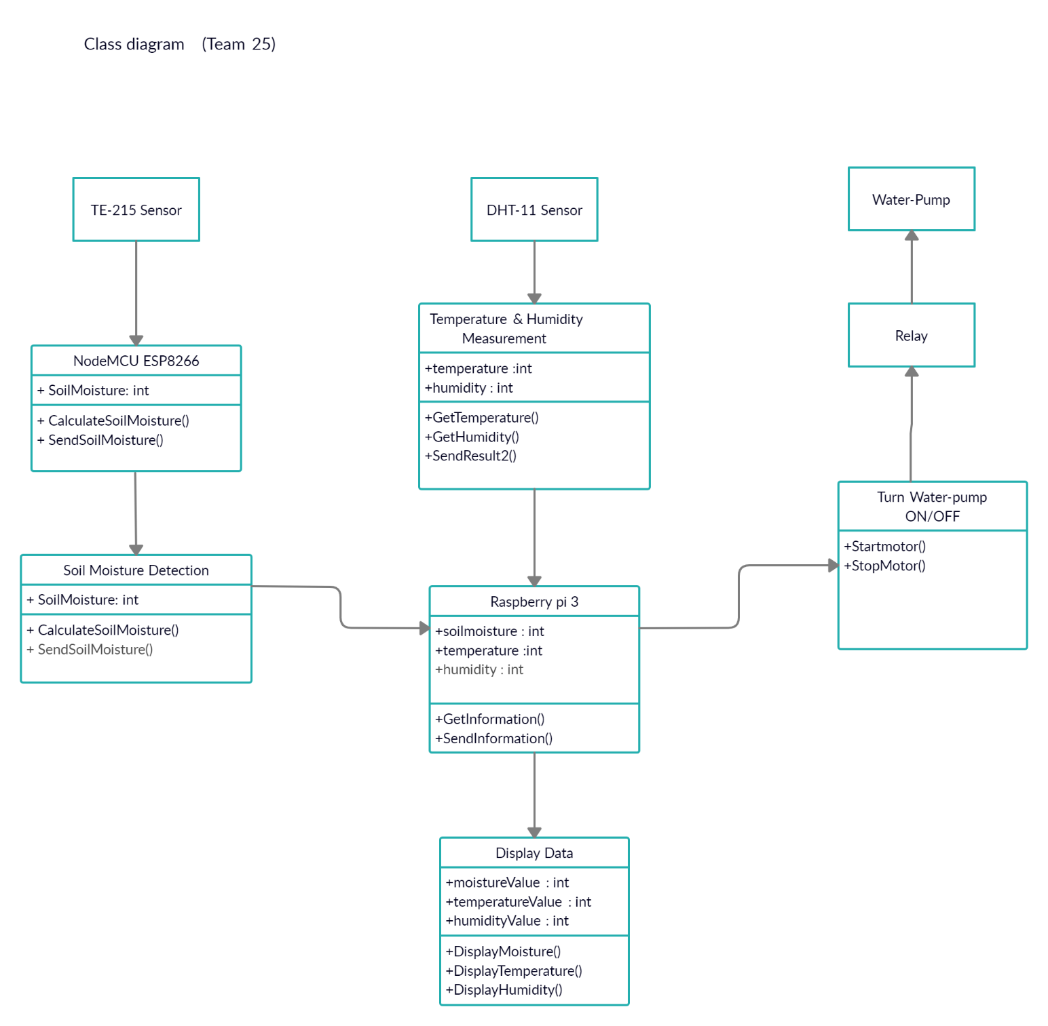

Figure 3-Class diagram

* + - 1. High-Level Diagram

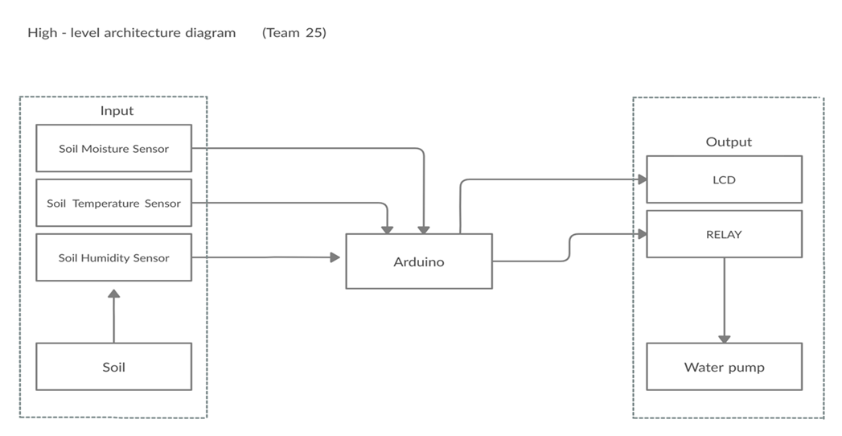

Figure 4-Highlevel diagram

* + - 1. Entity Relationship Diagram

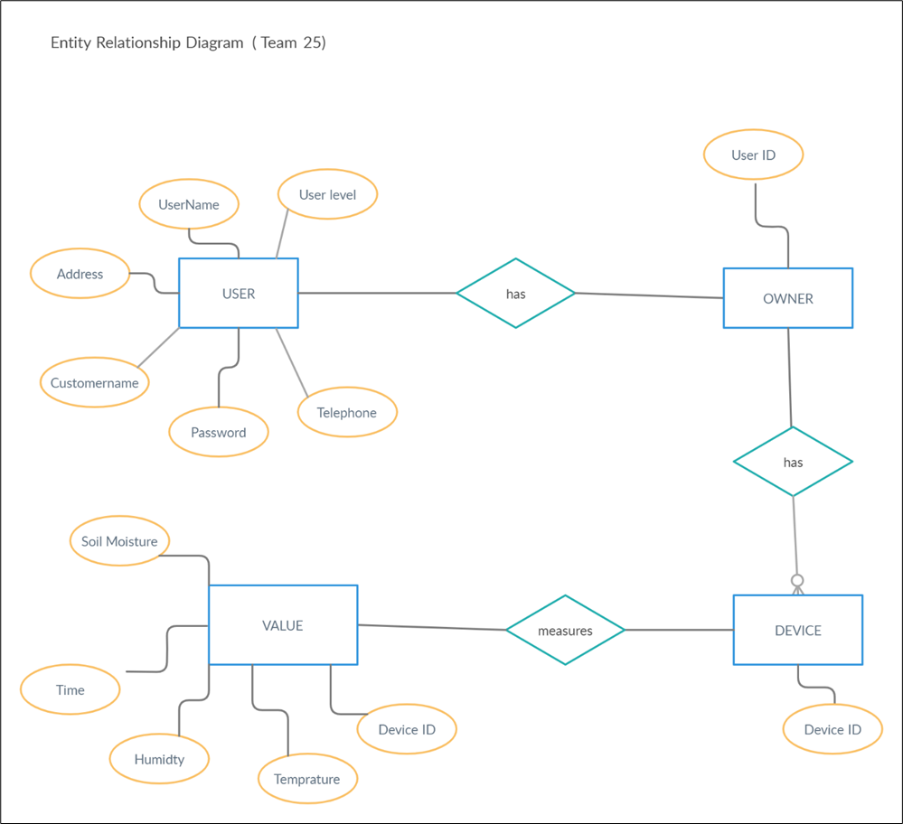

Figure 5-ER diagram

* + 1. Development tools and technology
       1. Development methodology
* Discuss ideas and made a list of materials.
* Draw project sketch and make assumptions of measurements and connections.
* Start making a prototype of the project.
* To hold the plants, a planter structure will be made from wood.
* Then fit the bottom panel and cut wholes to connect water pipes.
* The flow of water is controlled by using a solenoid valve.
* Then Start working on the sensor compartment and make all wires connect to each device.
* Then Programming the Raspberry Pi.
* Started on other programming parts.
* Then connected all programming codes together for the project and test all sensors.
* Plant crops inside the wood planter and make test runs to make sure everything works (as we use different conditions for each sensor).
* Then divided the tasks among members. Like report writing and working on software parts which is programming of mobile application.
* Then setting up the application.
* Finally connect all together and run the system.

**Work flow**

* Turn ON the system
* Then the system has the ability of initializing on Arduino Uno.
* The water level of the motor is frequently observed by the water level sensors.
* The soil moisture level, temperature and humidity readings taken using soil moisture, humidity & temperature sensors.
* If the permitted water level gets dropped the RELAY activates the motor that is integrated to the Arduino Uno.
* Likewise, when the soil gets dry (according to the readings of the sensors), the motor that is connected to the relay turns ON, in order to pump water to make the agricultural lands moisturized and wet.
  + - 1. Programming languages and tools

**Tools**

* Android Studio
* Latest version of Raspbian
* Arduino IDE

**Programming languages**

* Java - Because of object-oriented programming concepts.
  + - 1. Third Party Components and Libraries. (Optional)

Third Party Components and Libraries will not be use in this Automatic Plant Watering Irrigation System.

* + - 1. Algorithms

Decision Tree Algorithm

[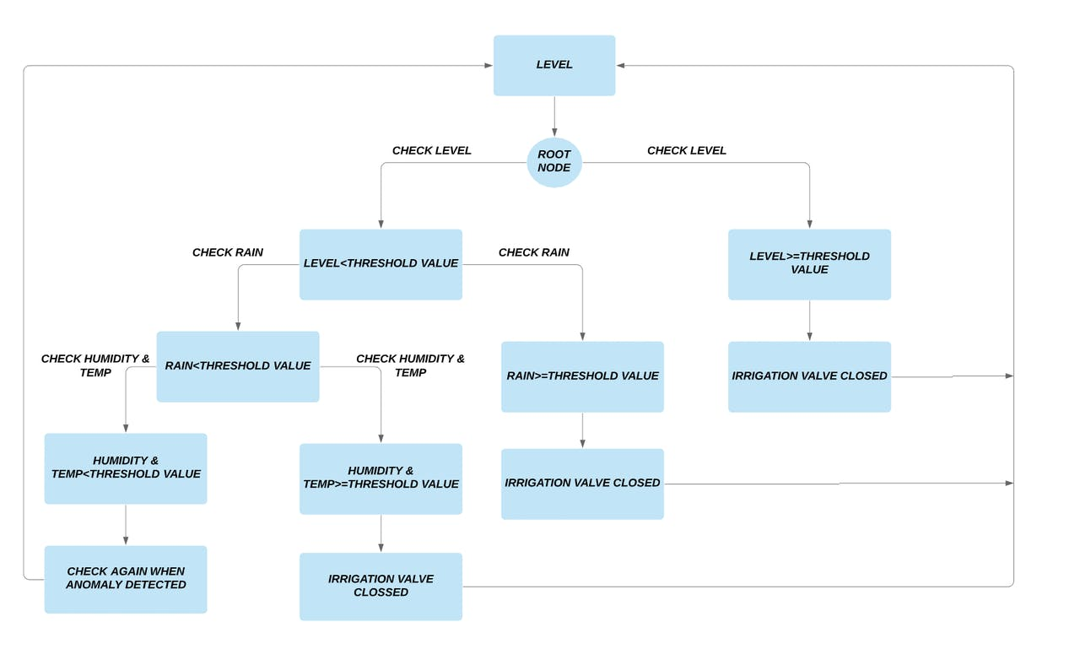](mailto:https://hackster.imgix.net/uploads/attachments/1100992/flow3_kltAsSDkKe.PNG?auto=compress%2Cformat&w=1280&h=960&fit=max)

#### Source code

**Web Application, Arduino Programming and database**

<https://github.com/thxru/APWIS>

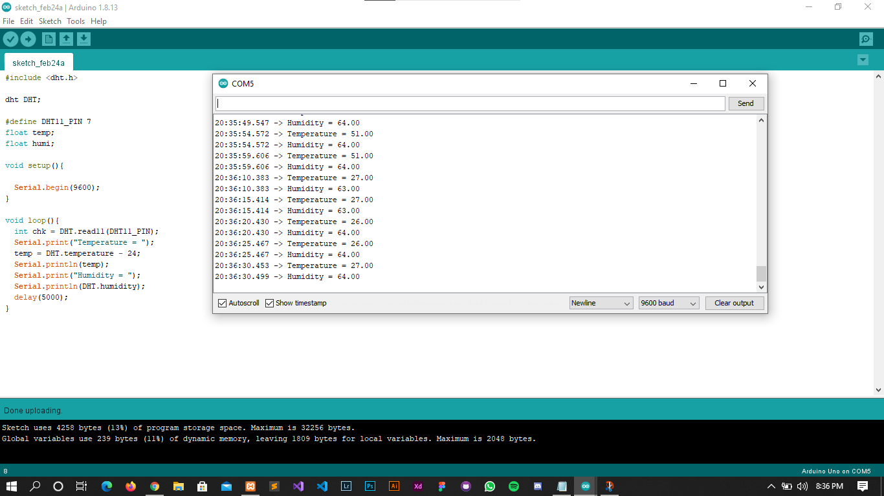

#### Screenshots and images

**Web Application**

* **Home Page**

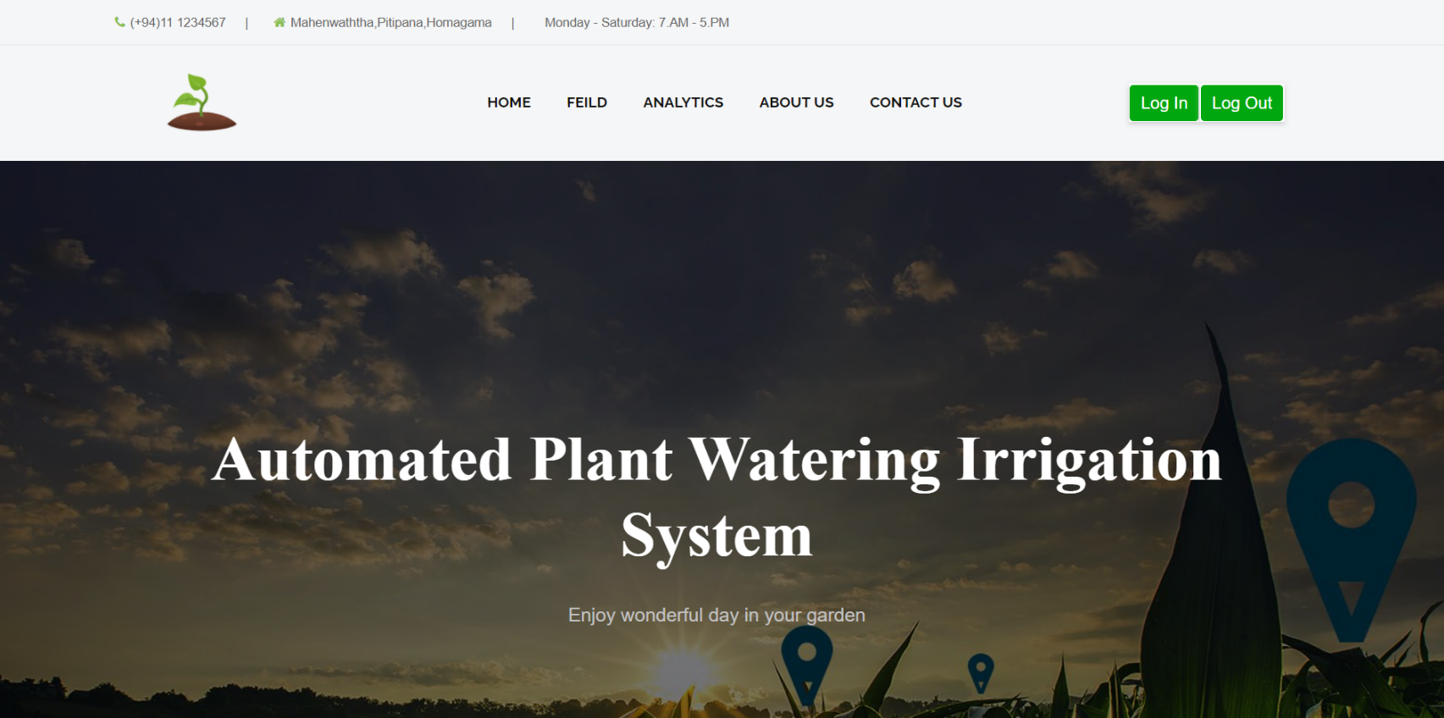

Figure 6-Homepage 1

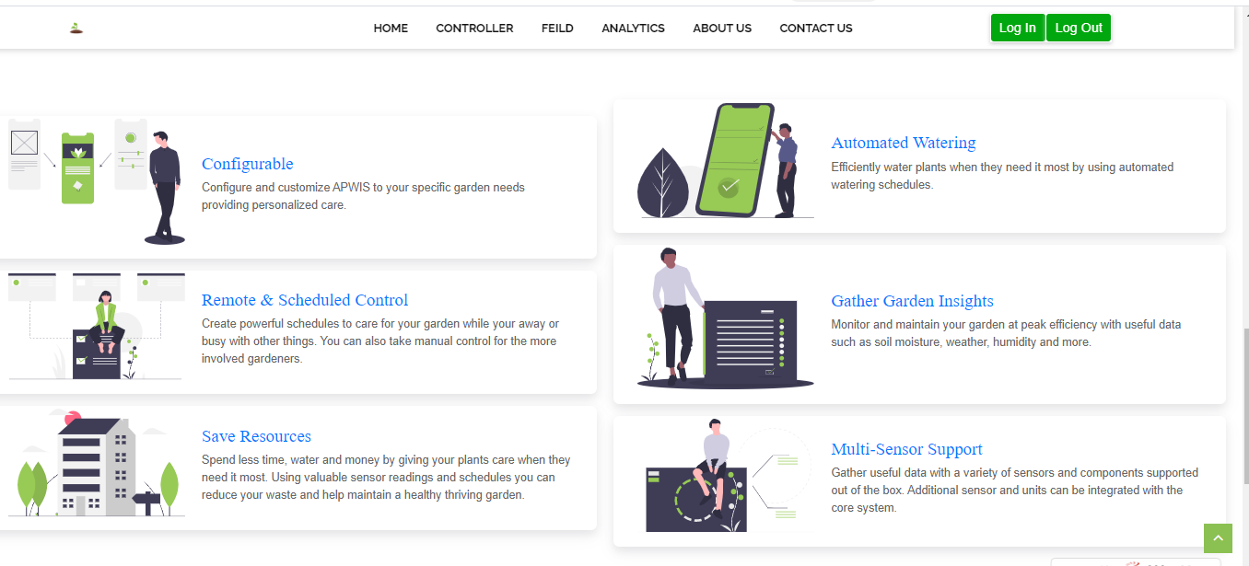

Figure 7-homepage 2

**•** **Controller Page**

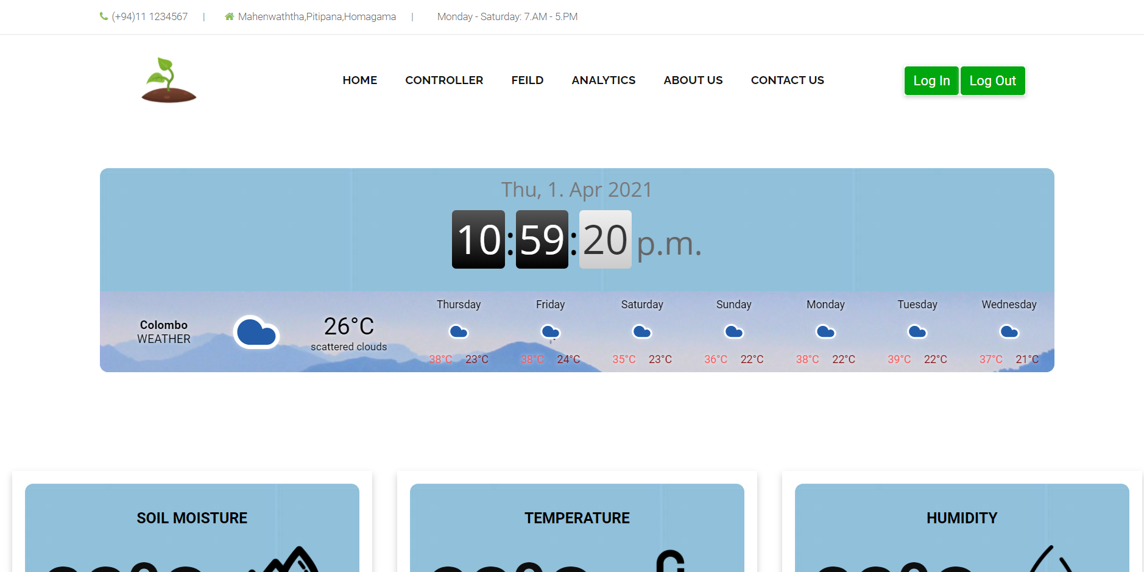

Figure 8-controller page 1

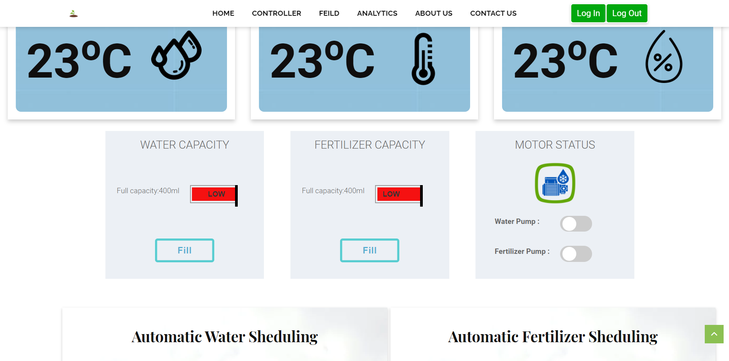

Figure 9-controller page 2

* **Validations**

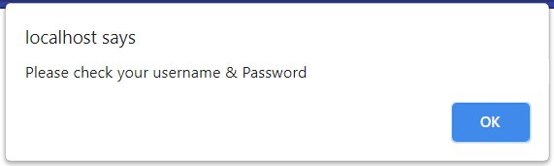

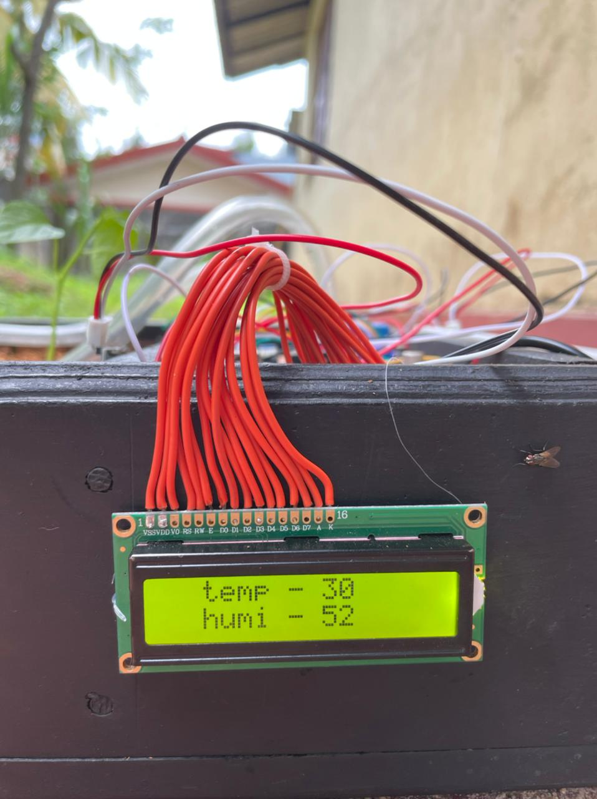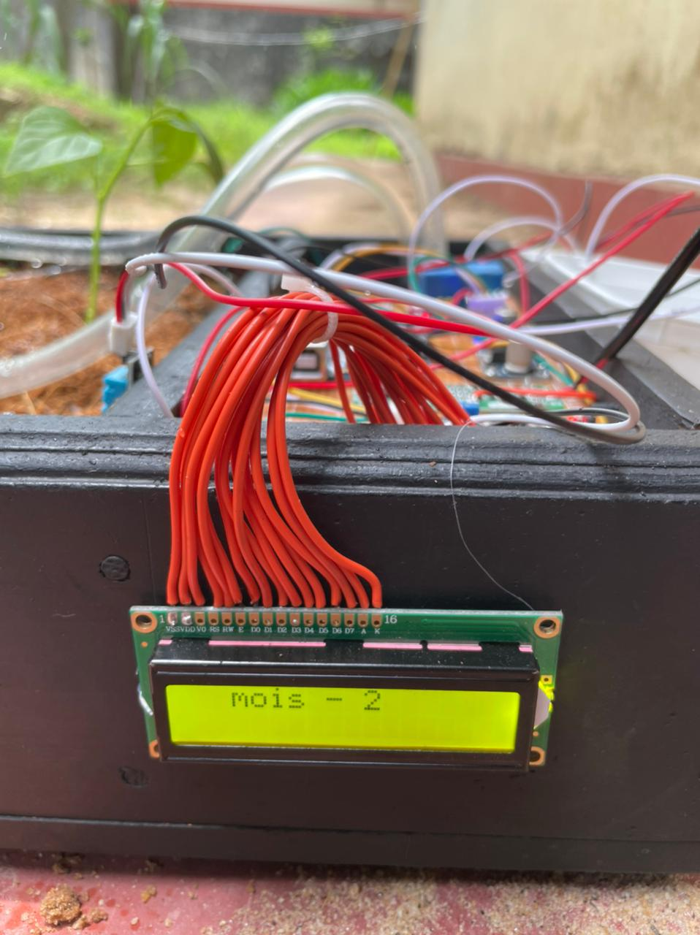**Prototype Structure**

Figure 10-prototype 1

Figure 11-prototype 2

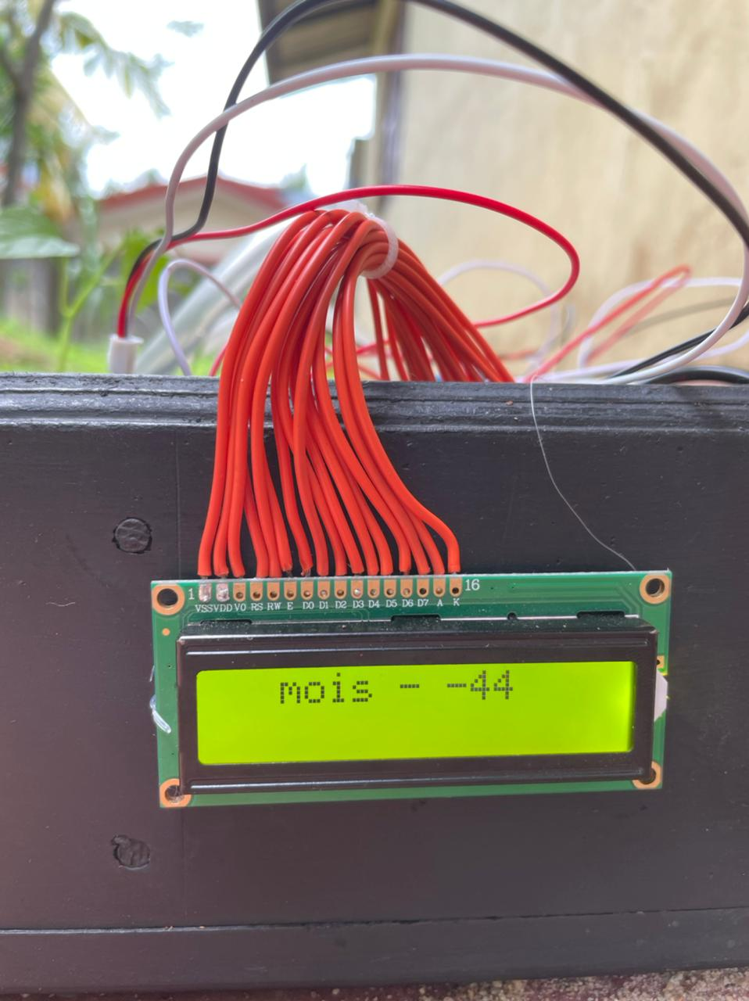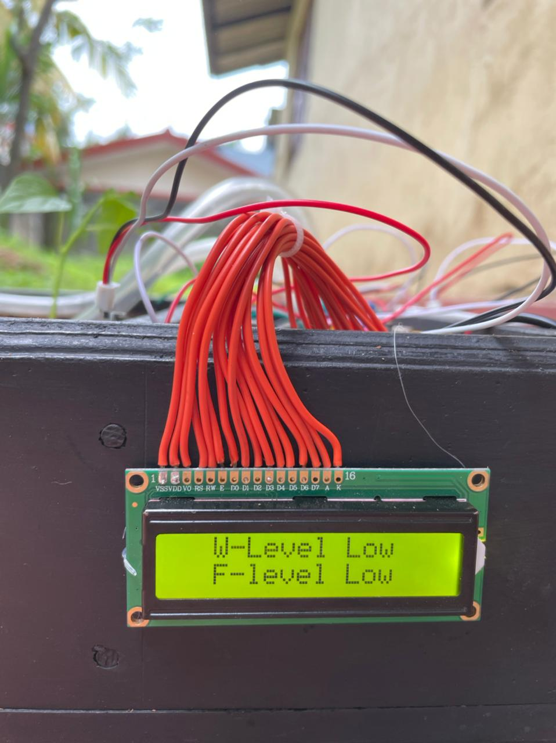

Figure 12-prototype 4

Figure 13-prototype 3

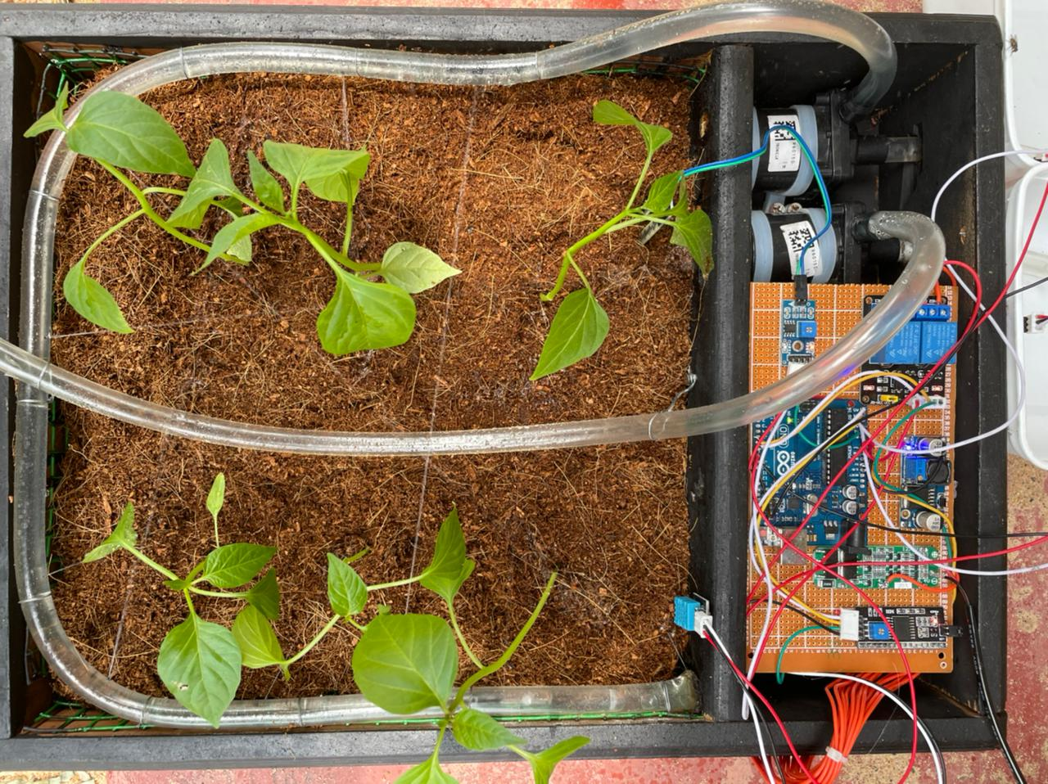

Figure 14-APWIS SYSTEM

**Testing**

* **Errors**

Table 17-error 1

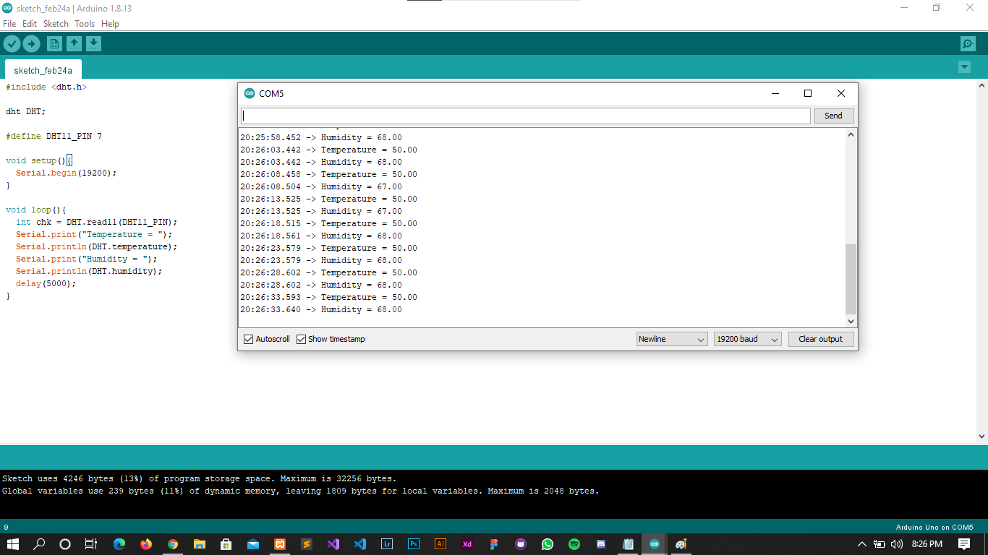

Table 18-error 2

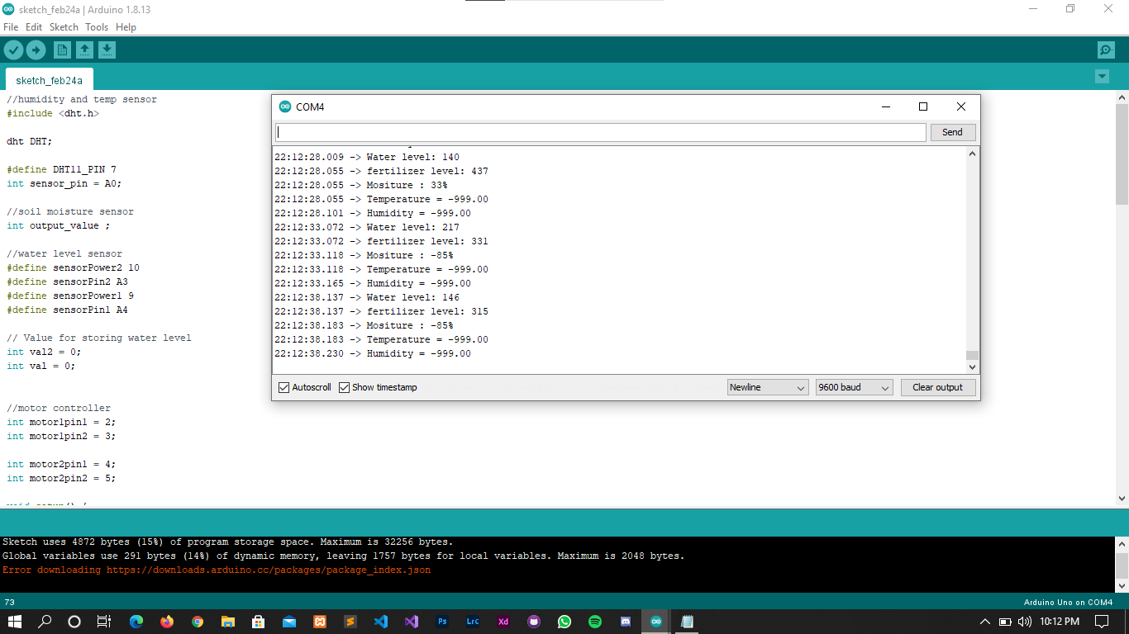

* **Arduino Testing**

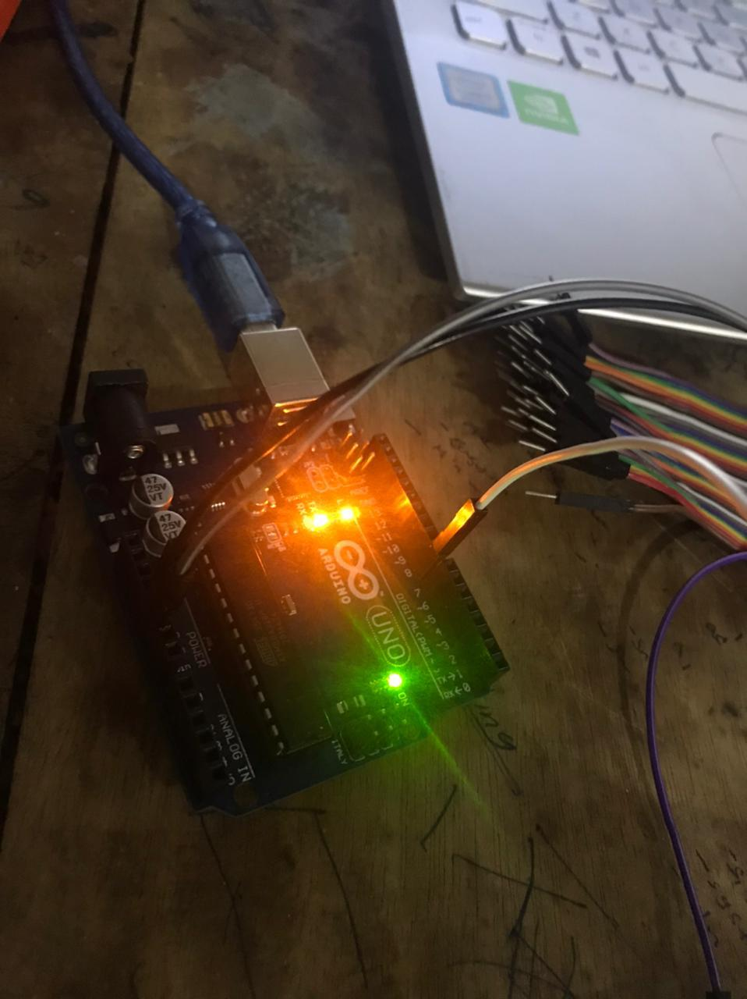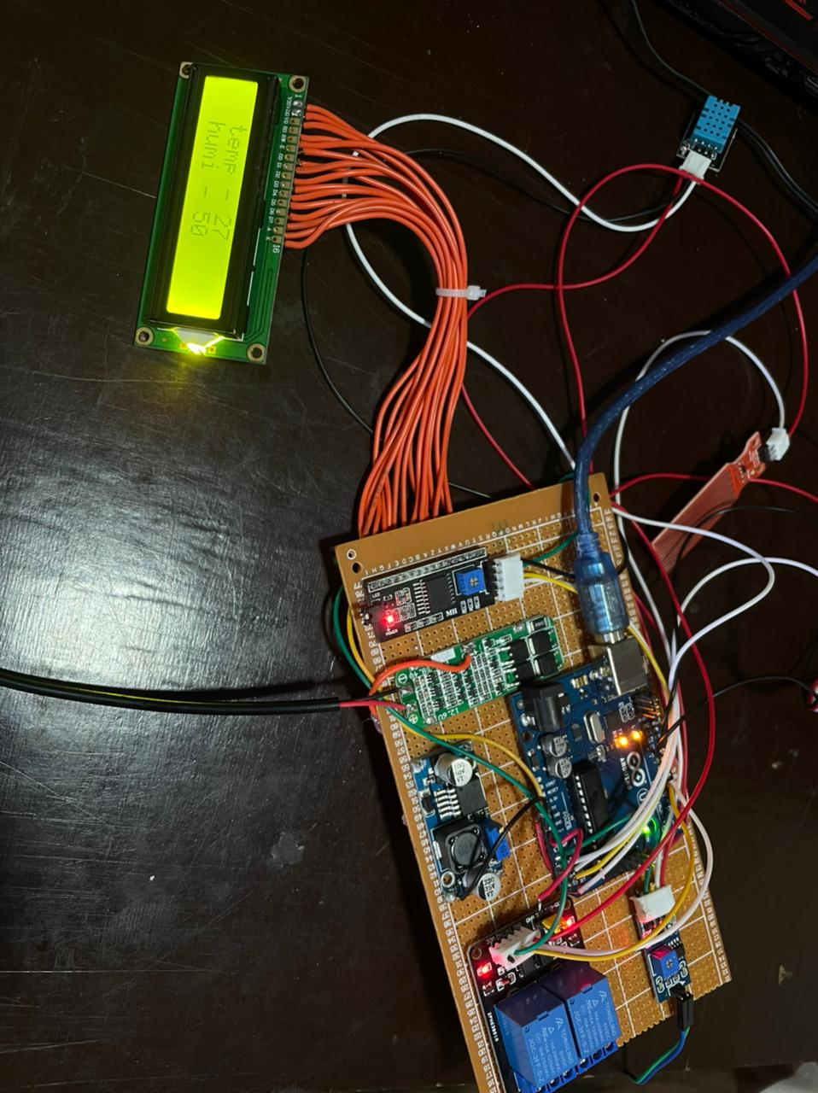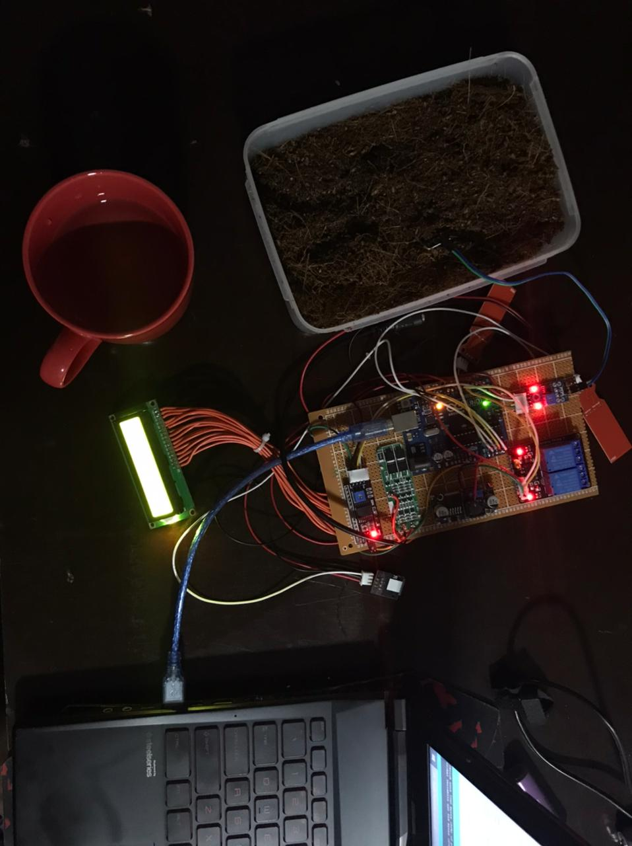

Figure 15-TESTING 3

Figure 16-TESTING 2

Figure 17-TESTING 1

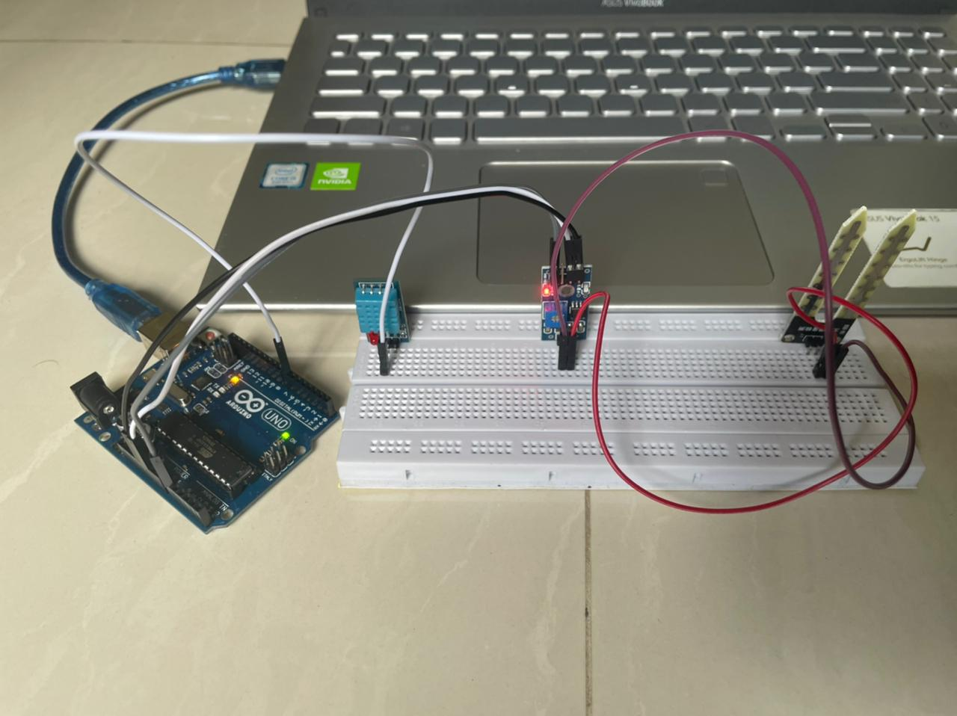

Figure 18-TESTING 4

* 1. References

1. Anon., 2020. *Impact of COVID19 on food supply chains in Sri Lanka.* [Online]   
   Available at: https://www.netherlandsandyou.nl/latest-news/news/2020/06/02/impact-of-covid19-on-food-supply-chains-in-sri-lanka  
   [Accessed 28 10 2020].
2. Connolly, T. & Begg, C., 2005. *DATABASE SYSTEMS : A Practical Approach to Design, Implementation, and Management.* 4th ed. England: Pearson Education Limited.
3. Dagur, E., Mishra, . S. & Y, S., 2017. *Intelligent IoT Based Automated Irrigation System.* [Online]   
   Available at: https://www.semanticscholar.org/paper/Intelligent-IoT-Based-Automated-Irrigation-System-Shekhar-Dagur/c968fac98241df0a5201dae514cbd1d5ab3cbf55/figure/9  
   [Accessed 2020].
4. Frost, J., 2019. *9 Essential Tips for Growing a Successful Crop.* [Online]   
   Available at: https://www.hobbyfarms.com/growing-crop-tips-farming-crops/  
   [Accessed 28 10 2020].
5. Lanka, F. S., 2018. *Soil Pollution: a danger lurking beneath our feet.* [Online]   
   [Accessed 2020].
6. Lanka, F. S., 2018. *Soil Pollution: a danger lurking beneath our feet.* [Online]   
   Available at: http://www.fao.org/srilanka/news/detail-events/en/c/1173507/  
   [Accessed 28 10 2020].
7. Naik, P., Kumbi, A., Katti, K. & Telkar, N., 2018. AUTOMATION OF IRRIGATION SYSTEM USING IoT. *International Journal of Engineering and Manufacturing Science,* 8(1), pp. 77-88.
   1. References
8. Anon., 2020. *Impact of COVID19 on food supply chains in Sri Lanka.* [Online]   
   Available at: https://www.netherlandsandyou.nl/latest-news/news/2020/06/02/impact-of-covid19-on-food-supply-chains-in-sri-lanka  
   [Accessed 28 10 2020].
9. Connolly, T. & Begg, C., 2005. *DATABASE SYSTEMS : A Practical Approach to Design, Implementation, and Management.* 4th ed. England: Pearson Education Limited.
10. Dagur, E., Mishra, . S. & Y, S., 2017. *Intelligent IoT Based Automated Irrigation System.* [Online]   
    Available at: https://www.semanticscholar.org/paper/Intelligent-IoT-Based-Automated-Irrigation-System-Shekhar-Dagur/c968fac98241df0a5201dae514cbd1d5ab3cbf55/figure/9  
    [Accessed 2020].
11. Frost, J., 2019. *9 Essential Tips for Growing a Successful Crop.* [Online]   
    Available at: https://www.hobbyfarms.com/growing-crop-tips-farming-crops/  
    [Accessed 28 10 2020].
12. Lanka, F. S., 2018. *Soil Pollution: a danger lurking beneath our feet.* [Online]   
    [Accessed 2020].
13. Lanka, F. S., 2018. *Soil Pollution: a danger lurking beneath our feet.* [Online]   
    Available at: http://www.fao.org/srilanka/news/detail-events/en/c/1173507/  
    [Accessed 28 10 2020].
14. Naik, P., Kumbi, A., Katti, K. & Telkar, N., 2018. AUTOMATION OF IRRIGATION SYSTEM USING IoT. *International Journal of Engineering and Manufacturing Science,* 8(1), pp. 77-88.
15. Pawar, S. B., Rajput, . P. & A. S., 2018 . *Smart Irrigation System Using IOT And Raspberry Pi,* 5(8).
16. Purandare, V., n.d. *Water Use Efficiency & Economic Feasibility of Irrigation Projects:.*

**\*\*\*THE END\*\*\***